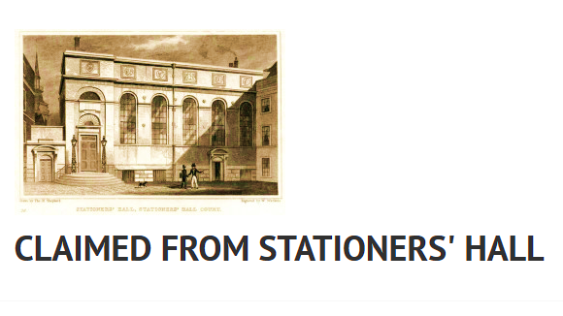
Monday 26th March, 11 am – 4 pm
Music Research Network Workshop - RCS Board Room

DELEGATES LIST
Giles Bergel University of Oxford
Almut Boehme National Library of Scotland
Stephen Broad Royal Conservatoire of Scotland (morning)
Morag Greig Glasgow University Library (until 3 pm)
Briony Harding St Andrews University Library
Elizabeth Henderson St Andrews University Library
Martin Holmes Bodleian Libraries
Margaret Jones Cambridge University Library
Robert Maclean Glasgow University Library (afternoon)
Karen McAulay Royal Conservatoire of Scotland
[Eva Moreda Rodriguez University of Glasgow – apologies]
Jane Pirie Aberdeen University Library
Elizabeth Quarmby-Lawrence University of Edinburgh
Rupert Ridgewell British Library
Brianna Robertson-Kirkland Royal Conservatoire of Scotland/ Glasgow Uni
Stephen Rose Royal Holloway University College
Matt Sangster University of Glasgow
Roy Stanley Trinity College Dublin University Library
Helen Vincent National Library of Scotland

AGENDA

Morning
11 am - Welcome with coffee
Introducing ourselves, our libraries, our research interests
Before lunch
Brianna sings 3 Napoleonic era songs by women (from St Andrews’ Vol.40)
1 pm - Lunch
Afternoon
Discussion – threads and themes, future directions, impact
3 pm – tea as we talk
4 pm – finish

Dinner, anyone?

